./

GENESIS - Learning Outcome & Mini-project Summary Report



|  |  |  |  |  |  |
| --- | --- | --- | --- | --- | --- |
| **Ver. Rel. No.** | **Release Date** | **Prepared. By** | **Reviewed By** | **To be Approved** | **Remarks/Revision Details** |
| 1. | 11-Nov-2020 | Harshavardhan C.A (99002634)  Y Sushank (99002649)  MVNSK Aditya (99002471) |  |  |  |
|  |  |  |  |  |  |
|  |  |  |  |  |  |
|  |  |  |  |  |  |
|  |  |  |  |  |  |

**Details**

Table of Contents

Table of Contents 3

List of Figures 4

List of Tables 5

Mini project -1 [Team] 6

Module: Core Java 6

Topic and Subtopics: 6

Interest Calculation of Savings account 6

Interest Calculation of Fixed deposit account 6

Interest Calculation of Recurring deposit account 6

Objectives & Requirements 7

Objectives 7

Low level requirements 7

High level requirements 7

Design 8

Structural Diagrams 8

Behavioral Diagram 8

Test Plan 9

Implementation Summary 10

13

Individual Contribution & Highlights 14

Summary 14

Challenges faced and how were they overcome 14

# List of Figures

Figure 1: Use Case Diagram 8

Figure 2: Object Diagram 8

Figure 3 :GitHub Dashboard 11

Figure 4: Build Badge 12

Figure 5: Code Quality Badge 12

Figure 6: Unit Test Cases 13

# List of Tables

Table 1: Low Level Requirements 7

Table 2: High Level Requirements 7

Table 3: Test Plan 9

# Mini project -1 [Team]

# Module: Core Java

## Topic and Subtopics:

Whether you are a housewife or a college student, a business owner or a business house, a retired professional or Indian living abroad, not having a bank account is unimaginable. Based on the purpose, frequency of transaction, and location of the account-holder, banks offer a bouquet of bank accounts to choose from. Here is a list of some of the types of bank accounts in India.

### Interest Calculation of Savings account

A savings bank account is a regular deposit account, where you earn a minimum rate of interest. Here, the number of transactions you can make each month is capped. Banks offer a variety of savings accounts based on the type of depositor, features of the product, age or purpose of holding the account, and so on. There are regular savings accounts, savings accounts for children, senior citizens or women, institutional savings accounts, family savings accounts, and so many more.

### Interest Calculation of Fixed deposit account

To park your funds and earn a decent rate of interest on it, there are different types of accounts.   
A fixed deposit (FD) account allows you to earn a fixed rate of interest for keeping a certain sum of money locked in for a given time, that is until the FD matures. FDs range between a maturity period of seven days to 10 years. The rate of interest you earn on FDs will vary depending on the tenure of the FD. Generally, you cannot withdraw money from an FD before it matures. Some banks offer a premature withdrawal facility. But in that case, the interest rate you earn is lower.

### Interest Calculation of Recurring deposit account

A recurring deposit (RD) has a fixed tenure. You need to invest a fixed sum of money in it regularly -- every month or once a quarter -- to earn interest. Unlike FDs, where you need to make a lump sum deposit, the sum you need to invest here is smaller and more frequent. You cannot change the tenure of the RD and the amount to be invested each month or quarter. Even in the case of RDs, you face a penalty in the form of a lower interest rate for premature withdrawal. The maturity period of an RD could range between six months to 10 years.

## Objectives & Requirements

### Objectives

Interest calculator for different types of accounts like current, savings, fixed deposit and recurring deposit accounts.

### Low level requirements

1. Amount
2. Time period
3. Age

### High level requirements

1. Fixed deposit account
2. Recurring deposit account
3. Savings account

**Low level Requirements:**

|  |  |
| --- | --- |
| **ID** | **Description** |
| L1 | Amount deposited in the account. |
| L2 | Time for which the amount is deposited into the account. |
| L3 | Age of the person who is depositing the amount into the account. |

Table 1: Low Level Requirements

**High Level Requirements:**

|  |  |
| --- | --- |
| **ID** | **Description** |
| H1 | Fixed deposit is a type of account in which the amount is put and interest is obtained annually. |
| H2 | Recurring deposit is a type of account in which the amount is cut every month and interest is obtained annually. |
| H3 | Savings account is a widely used account in which the salary is put and interest is obtained according to the amount in the account. |
| L1_L2_H1 | Fixed account related to amount and time |
| L2_L1_H2 | Recurring account related to amount time and age |
| L2_H3 | Recurring account related to AGE |
| L2_H2 | Recurring account related to time |
| L1_H3 | Savings account depends on the amount deposited |
| L2_L1_H3 | Savings account depends on the amount and time |

Table 2: High Level Requirements

## Design

### Structural Diagrams

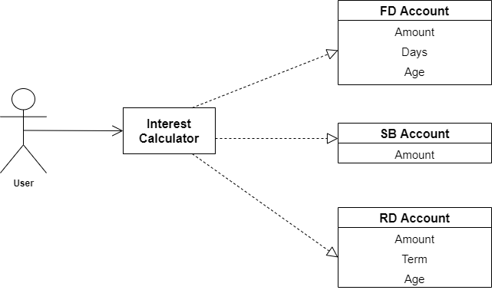

Figure 1: Use Case Diagram

### Behavioral Diagram

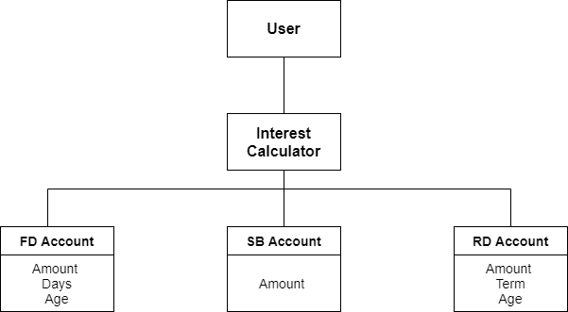

Figure 2: Object Diagram

## Test Plan

|  |  |  |  |
| --- | --- | --- | --- |
| **Requirement** | **Type** | **Description** | **Result** |
| L1 | Amount | Amount present in the account | Amount is obtained |
| L2 | Time Period | Time for which the amount was present in the account | Time period is obtained |
| L3 | Age | Age of the account holder | Age is obtained |
| L1_L2_H1 | Fixed account related to amount and time | The amount present in the fixed account will give the interest according to the time period | Interest is obtained |
| L2_L1_H2 | Recurring account related to amount time and age | The interest for recurring deposit is depending on the amount time and age | Interest is obtained according to age and time of the deposit |
| H1 | Fixed Deposit | Fixed account is the type of account discussed above | Fixed account is explained |
| H2 | Recurring Deposit | Recurring deposit is the type of deposit where every month some part of the amount is added and interest is obtained | Recurring deposit is made and interest is obtained |
| H3 | Savings Deposit | This is a very commonly used account for salaries by most of the employees | Savings account is obtained |
| L2_H3 | Recurring account related to AGE | The interest is obtained according to the age of the person | Interest is obtained according to the age |
| L2_H2 | Recurring account related to time | The interest is obtained to the time of money deposited in the account | Interest is obtained according to the time of amount deposited |
| L1_H3 | Savings account depends on the amount deposited | The amount deposited in the account | Interest is obtained according to the amount deposited |
| L2_L1_H3 | Savings account depends on the amount and time | The amount deposited in the account depends on time | Interest is obtained according to time |

Table 3: Test Plan

## Implementation Summary

**Fixed Deposit**

FD or a fixed deposit account is another type of bank account that can be opened in any Public or Private sector bank.

The list of important things that need to be known with respect to the fixed deposit account have been mentioned below:

* It is a onetime deposit and one time take away account. Under this type of account, the account holder needs to deposit a fixed amount of sum (as per their wish) for a fixed time period
* The amount deposited in FD account can only be withdrawn all at once and not in instalments
* Banks pays interest on the fixed deposit account
* The rate of interest depends upon the amount you deposit and for the time duration of the FD
* Full repayment of the amount is available before the maturity date of FD
* So the parameters like time and amount are required to find out the interest to the amount deposited.

**Recurring Deposit Account**

Recurring Deposit account or RD account is a form of account wherein the account holder needs to deposit a fixed amount every month until it reaches the fixed maturity date.

The features of the Recurring deposit account have been discussed below:

* Any individual or an Institution can open a recurring deposit account either separately or jointly
* Periodic or monthly installments that need to be added can be as low as Rs.50/- or may vary from bank to bank
* The range of months for which an RD account can be opened varies from 6 months to 120 months
* The interest rate varies depending upon the bank you choose to open an account with
* Nomination facility is also available for RC accounts
* Passbook is issued for this type of bank account
* Premature withdrawal of the amount is permitted, provided a sum of amount is deducted as penalty
* So the age amount and time, these 3 factors are used to calculate the interest of the deposit and interest is calculated

**Savings Account**

As the name suggests, the savings accounts can be opened by an individual or jointly by two people with an aim to save money. The main benefit of opening a savings bank account is that the bank pays you interest for opening this type of account with them.

Given below are a few features of the Savings account:

* There is no limit to the number of times the account holder can deposit money in this account but there is a restriction on the number of times money can be withdrawn from this account.
* The rate of interest that an account holder get varies from 4% to 6% per annum
* There is no minimum balance that needs to be maintained for this type of an account so any amount is accepted
* The interest is obtained according to the amount and time for which the amount is deposited into the account.
* In this type of account, the age is not considered.

**Video Summary**

[**https://github.com/99002634/2009MYSEMB03-Core-Java-3/blob/main/Java_miniproject/6_ImagesandVideos/Media2.zip**](https://github.com/99002634/2009MYSEMB03-Core-Java-3/blob/main/Java_miniproject/6_ImagesandVideos/Media2.zip)

**GitHub Link**

<https://github.com/99002634/2009MYSEMB03-Core-Java-3>

**GitHub Dashboard**

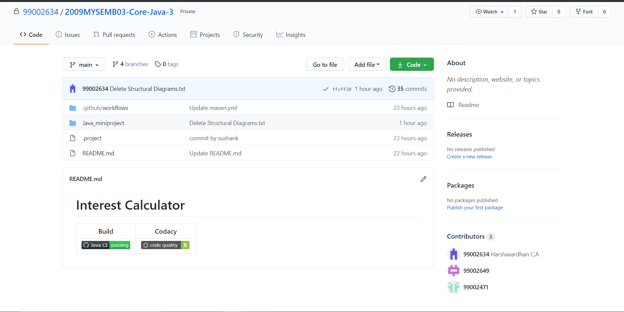

Figure 3 :GitHub Dashboard

**Summary**

The GitHub repository has the following files and each file has a README.md file which explains documentation of the project:

1. Requirements: This contains the high level and low level requirements of the project
2. Architecture: This contains the necessary UML diagrams present in the project
3. Implementation: This contains the source code of the following project
4. Test Plan and output: This contains the test plan and the obtained outputs of the project
5. Report: This contains the report of the project
6. Images and videos: This contains the images and the working of project

#### Build

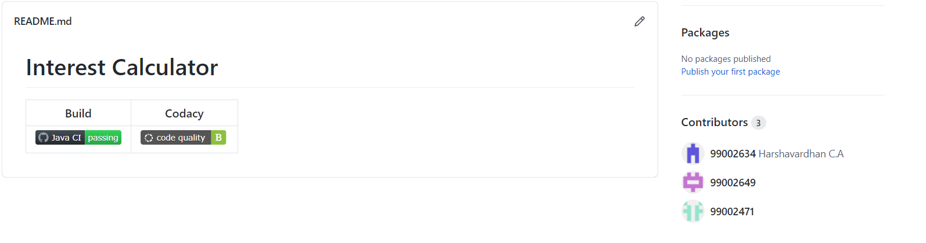The below screenshot below shows the Build and code quality of the project

Figure 4: Build Badge

#### Code quality and Issues or Bug Tracking

The below screenshot below shows the Build and code quality of the project



Figure 5: Code Quality Badge

**Bug Tracking:**

1. Initially the build got failed because of the error in creation of the account object.
2. Correcting the error, we got an another error Junit as the test cases were failing.
3. RD Account interest rate was given wrong
4. In FD forgot to add the dependency of number of days

#### Unit Testing

The test cases were done according to the type of accounts shown above:

1. **Fixed Deposit:** It is dependent on the amount deposited and the number of days which the amount is deposited.
2. **Recurring deposit**: It is dependent on the amount deposited per month, number of days and the age of the person who is depositing the amount.
3. **Savings deposit**: It is dependent on the amount deposited in the account its interest is obtained annually and is directly credited into the account.

The summary of the test cases is attached below:

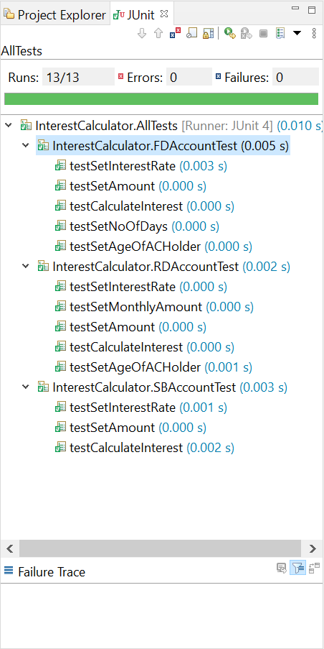

## 

Figure 6: Unit Test Cases

## Individual Contribution & Highlights

**99002471(M V N S K Aditya):**

1. Created the Java code and the test file for savings account
2. Created the main file and the test file for the main file

**99002649(Y Sushank):**

1. Created the Java code and the test file for fixed deposit account.
2. Created the maven build configuration for entire project

**99002634(Harshavardhan CA):**

1. Created the Java code and the test file for recurring deposit account
2. Code quality check using codacy platform was done.

### Summary

We implemented Interest calculator on three different types of accounts namely, FD Account, SB Account, and RD Account. FD Account Interest is calculated based on Amount, Days and Age, SB Account Interest is calculated based on Amount, and RD Account Interest is calculated based on Amount, term and Age of Account Holder.

Unit testing was performed using the Junit framework to verify the functionalities of all three types of accounts.

### Challenges faced and how were they overcome

1. Creating the test file for different accounts and configuring the Junit
2. Folder structure was lost while upload the maven project into the git
3. Creation of Maven build workflow was difficult

### 